

Sertin

**Multipurpose One Page HTML template**

**Created**: August 2014

**Latest Update**: 08 August 2014

**By**: MOSAIXEL

**Support desk** : [mosaixel.org@gmail.com](mailto:mosaixel.org@gmail.com) for fast reply

Thank you for purchasing my template. If you have any questions that are beyond the scope of this help file, please feel free to contact us at [mosaixel.org@gmail.com](mailto:mosaixel.org@gmail.com) for fast reply. Thanks so much!

Introduction

Sertin is a Responsive Multi-Purpose Parallax One Page HTML5 template, simple, clean, contrast, stylish and professional look. It suitable for Landing page, one page website, visual portfolios, web design company, personal page and business type page, It's a responsive template so it looks perfect in desktop, tablets and all mobile devices.

Files

You get some folders for necessary files and some HTML files:

* **CSS** : folder for Style Sheet
* **fonts**: folder for Awsome font files
* **images**: folder of some images for plugins
* **img**: folder for all images for the template
* **js**: folder for all javascript files
* **404.html**: HTML page for 404 error page
* **about.html**: HTML page for about us sections
* **animations.html**: HTML page for animations
* **blog.html**
* **blog-masonry-2-columns.html**
* **blog-masonry-2-columns-sidebar.html**
* **blog-masonry-3-columns.html**
* **blog-single.html**
* **contact.html**: HTML page for contact sections
* **footer.html**: HTML page for footer sections
* **icons.html**: HTML page for icons
* **index.html**: HTML page for home page style 1
* **index_2.html**: HTML page for home page style 2
* **index_3.html**: HTML page for home page style 3
* **index_4.html**: HTML page for home page with Parallax Slider Background
* **index_5.html**: HTML page for home page with Full Video Background
* **index_6.html**: HTML page for home page with animated background
* **index_7.html**: HTML page for home page with Pattern Background
* **index_8.html**: HTML page for home page with solid background
* **list.txt**: text file for subscribers email list
* **mailer.php**: PHP file that send emails with PHP
* **menu.html**: HTML page for menu sections
* **portfolio-item-1.html**: HTML file for portfolio project style 1
* **portfolio-item-2.html**: HTML file for portfolio project style 2
* **portfolio-item-3.html**: HTML file for portfolio project style 3
* **portfolio-item-4.html**: HTML file for portfolio project style 4
* **portfolio-item-5.html**: HTML file for portfolio project style 5
* **price.html**: HTML page for price sections
* **product.html**: HTML page for product sections
* **service.html**: HTML page for service sections
* **shortcodes.html**: HTML page for shortcodes
* **skills.html**: HTML page for skills sections
* **statics.html**: HTML page for statics sections
* **subscribe.html**: HTML page for subscribe & action sections
* **subscribe.php**: PHP file for subscription functions
* **team.html**: HTML page for team sections
* **testimonial.html**: HTML page for testimonials sections

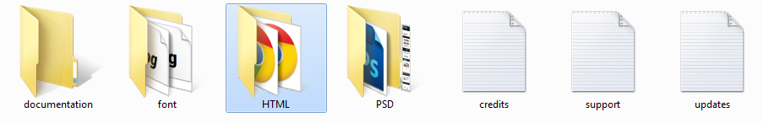

**CSS: Style Sheet files**

* **animate.css**: CSS file for animation plugins
* **bootstrap.css**: Bootstarp default file
* **color_1.css**: CSS File for colors
* **color_2.css**: CSS File for colors
* **color_3.css**: CSS File for colors
* **color_4.css**: CSS File for colors
* **color_5.css**: CSS File for colors
* **color_6.css**: CSS File for colors
* **color_7.css**: CSS File for colors
* **color_8.css**: CSS File for colors
* **color_9.css**: CSS File for colors
* **color_10.css**: CSS File for colors
* **color_11.css**: CSS File for colors
* **color_12.css**: CSS File for colors
* **color_13.css**: CSS File for colors
* **color_14.css**: CSS File for colors
* **color_15.css**: CSS File for colors
* **color_16.css**: CSS File for colors
* **color_17.css**: CSS File for colors
* **color_18.css**: CSS File for colors
* **color_19.css**: CSS File for colors
* **color_20.css**: CSS File for colors
* **filters.svg**: SVG file for grey effect on hover
* **font-awsome.min.css**: defualt CSS file for font awsome plugin
* **jquery.bxslider.css**: Default CSS file for bxslider plugin
* **awl.carousel.css**: default CSS file for AwlCarousel plugin
* **prettyPhoto.css**: Default CSS file for PrettyPhoto plugin
* **reset.css**: CSS file to reset values for all browsers
* **style.css**: CSS file for template styles

**js: JavaScript files**

* **twitter [folder]**:Folder for tweets plugin
* **bootstrap.min.js**: JS file for bootstrap components
* **enquire.min.js**: JS file for enquire plugin
* **gmap3.min.js**: JS file for google map plugin
* **jquery.appear.js**: JS file for appear plugin
* **jquery.bxslider.min.js**: JS file for bxslider plugin
* **jquery.countTo.js**: JS file for count plugin
* **jquery.easing.1.3.js**: JS file for easing plugin
* **jquery.easy-pie-chart.js**: JS file for easy pie chart plugin
* **jquery.fitvids.js**: JS file for fitvids plugin
* **jquery.isotope.min.js**: JS file for isotope plugin
* **jquery.jplayer.min.js**: JS file for jplayer plugin
* **jquery.mb.YTPlayer.js**: JS file formb.YTPlayer plugin
* **jquery.nav.js**: JS file for nav plugin
* **jquery.nicescroll.js**: JS file for nicescroll pugin
* **jquery.prettyPhoto.js**: JS file for pretty Photo plugin
* **jquery.sticky.js**: JS file for sticky plugin
* **jquery.superslides.min.js**: JS file for super slides plugin
* **jquery-1.11.0.min.js**: JS file for jQuery
* **masonry.js**: JS file for masonry plugin
* **modernizr-latest.js**: JS file for modernizer
* **owl.carousel.min.js**: JS file for owl carousel plugin
* **script.js**: JS file for custom jquery queries for the template
* **script_masonry2b.js**: JS file for custom query for masonry blog
* **script_masonryb.js**: JS file for custom query for masonry blog
* **wow.min.js**: JS file for Wow animations plugin

HTML Structure

This template is developed by Bootstrap framework. Code is well organized and commented. See the complete reference structure of the template.

Each block on the HTML page is used as a section on the code. We used “container”, “row” “cols” classes from bootstrap framework to organize blocks.

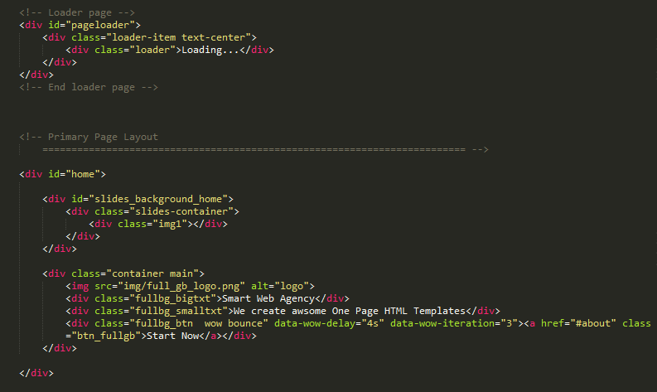

Bootstrap Framework Setup

Sertin is completely built with Bootstrap 3.0.3 responsive framework which is the best front-end development framework available at present. It is very easy to edit the layout as well as for making any advanced customization. Kindly note, you have to familiarize Bootstrap’s native arrangements (it is easy) and short codes before you proceed.

**Bootstrap’s grid system**

The default Bootstrap grid system utilizes 12 columns, with the responsive CSS file added, the grid adapts to be 724px, 940px and 1170px wide depending on your viewport.

Below 767px viewports, the columns become fluid and stack vertically.



**Setting up the grid – HTML**

For a simple two column layout, create a .row and add the appropriate number of . col-md* columns. As this is a 12- column grid, each . col-md* spans a number of those 12 columns, and should always add up to 12 for each row (or the number of columns in the parent). Please see the markup:

<div class="row">

<div class="col-md-1">.col-md-1</div>

<div class="col-md-1">.col-md-1</div>

<div class="col-md-1">.col-md-1</div>

<div class="col-md-1">.col-md-1</div>

<div class="col-md-1">.col-md-1</div>

<div class="col-md-1">.col-md-1</div>

<div class="col-md-1">.col-md-1</div>

<div class="col-md-1">.col-md-1</div>

<div class="col-md-1">.col-md-1</div>

<div class="col-md-1">.col-md-1</div>

<div class="col-md-1">.col-md-1</div>

<div class="col-md-1">.col-md-1</div>

</div>

<div class="row">

<div class="col-md-8">.col-md-8</div>

<div class="col-md-4">.col-md-4</div>

</div>

<div class="row">

<div class="col-md-4">.col-md-4</div>

<div class="col-md-4">.col-md-4</div>

<div class="col-md-4">.col-md-4</div>

</div>

<div class="row">

<div class="col-md-6">.col-md-6</div>

<div class="col-md-6">.col-md-6</div>

</div>

We are having page limitation to explain everything about Bootstrap here. So for more information we refer to original documentation for Bootstrap, found here: <http://getbootstrap.com/>

**Disabling responsiveness**

Bootstrap automatically adapts your pages for various screen sizes. Here's how to disable this feature so your page works like in this non-responsive example.

Steps to disable page responsiveness

Omit the viewport <meta> mentioned in the CSS docs

Override the width on the .container for each grid tier with a single width, for example width: 970px !important; Be sure that this comes after the default Bootstrap CSS. You can optionally avoid the !important with media queries or some selector-fu.

For grid layouts, use .col-xs-* classes in addition to, or in place of, the medium/large ones. Don't worry, the extra-small device grid scales to all resolutions.

More information here : <http://getbootstrap.com/getting-started/#disable-responsive>

Top section

The top section present the full first screen, we have in this template 6 options

1. Full image background
2. Full Parallax Slider
3. Full Video Background
4. Full Animated Background
5. Full Pattern Background
6. Full Solid Background

So, let’s take those 6 options:

# Full image background:

The file index.html represents this feature and to change the image on the background you need to change this part of the code

<div id="slides_background_home">

<div class="slides-container">

<div class="img1"></div>

</div>

</div>

We have included 20 ready background to use, you can use from 1 to 20 ready background images found on the IMG folder or you can edit this part on the css file “style.css” and create your own background

#slides_background_home .slides-container .img1{

background:url(../img/bg6.jpg) center fixed ;

}

# Full Parallax Slider

The file index_4.html include on top this feature, so to edit the slider you have this part of the code

<div class="slides-container">

<div class="img1"></div>

<div class="img2"></div>

<div class="img3"></div>

<div class="img4"></div>

</div>

Each div is a background image, in this example we have 4 images in the slider, you can add as many images you want and you can custom your images by choosing the image number or you can custom your own background from CSS style.css file as this one

#slides_background_home .slides-container .img1{

background:url(../img/bg6.jpg) center fixed ;

}

# Full Video Background

The file index_5.html includes this feature and the video is a youtube video and can be edited from this part on the HTMl code:

<div class="slides-container">

<!-- Video -->

<div id="P3" class="player video-container" data-property="{videoURL:'-VL_G4SNaGM',containment:'#slides_background',autoPlay:true, mute:true, startAt:0, opacity:0.5}"></div>

<!-- End Video -->

</div>

You can change this value by the URL od the youtube video, just delete the part http://www.youtube.com/watch?v= and let the other part like this 🡺

http://www.youtube.com/watch?v=-VL_G4SNaGM

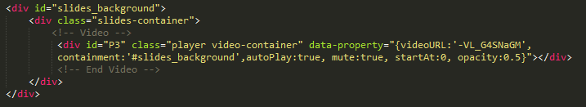

So options can be changed:

* **opacity**: 1 //(int) 0 → Set the opacity of the player;
* **mute**: true //(boolean) mute the audio;
* **showControls**: true // or false If you set the player as background you can show controls adding this parameter;
* **ratio**: ‘4/3’ or “16/9” to set the aspect ratio of the movie;
* **quality**: ‘default’ or “small”, “medium”, “large”, “hd720”, “hd1080”, “highres”;
* **containment**: (string) the CSS selector of the DOM element where you want the video background; if not specified it takes the “body”; if set to “self” the player will be instanced on that element;
* **optimizeDisplay**: true (boolean) will fit the video size into the window size optimizing the view;
* **loop**: true (boolean) or false loops the movie once ended.
* **vol**: 1 to 100 (number) set the volume level of the video.
* **startAt**: 20 (int) Set the seconds the video should start at.
* **autoplay**: true (boolean) or false play the video once ready.
* **showYTLogo**: true (boolean) Show or hide the YT logo and the link to the original video URL.
* **showControls**: true (boolean) Show or hide the controls bar at the bottom of the page.

# Full Animated Background

The file index_6.html includes this feature. The code is exactly as the simple image background, you can use any image but just add this class

<div class="slides-container">

<div class="img5 home_animated"></div>

</div>

And the background will be animated.

# Full Pattern Background

The file index_7.html includes this feature. You can change the pattern frim Style.css file from this part of the code :

#slides_background_home .slides-container .img6{

background:url(../img/pattern_2.png) center fixed ;

}

# Full Solid Background

The file index_8.html includes this feature and the color of the background is related to the color chosen for the template. So to change the color, you need to change the Color_X.css file or from the css color file used, on this code part:

#slides_background_home .slides-container .solid_bg{

background:#f48e0b center fixed ;

}



About Us Section

To make the about us section more beautiful and to have many possibilities, we have made the about us page about.html, that include many sections to make on the page.

To change the about us section, you only need to copy the code from about.html and to past it in your HTML page.

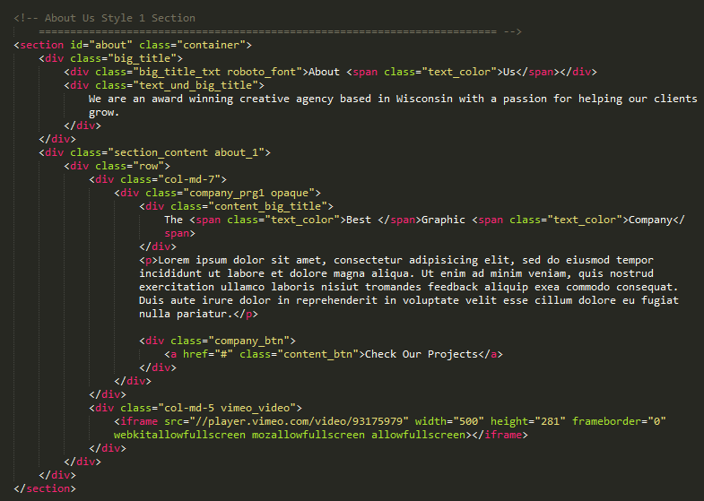

Our Company Section

This section is made especially for Sertin template, it include 4 blocks for 4 activities for the company. To edit it just go to “Our Company Section” on the code and make your changes. For images you need **270X148** image.

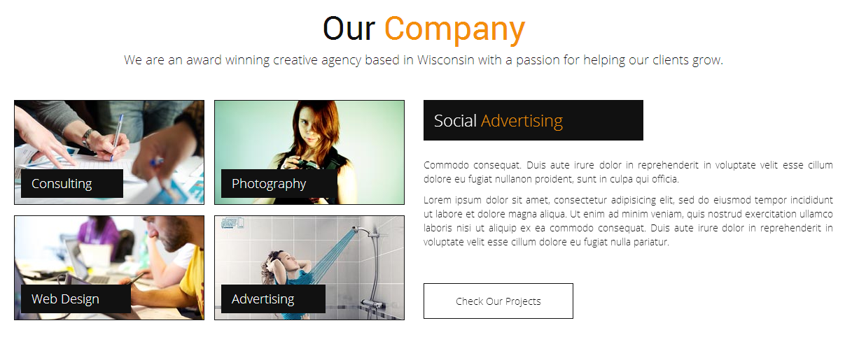

Simple Text Background Section

This is a simple section to display a short text. Colored text need to be in this code  
<span class="text_color"> to have the template color. To change the background you need to change the CSS part: background: url(../img/bg1.jpg) no-repeat 0 0 fixed;

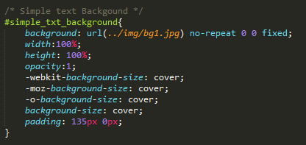

Our Team Section

We have made this section to make the possibility to add many persons on the team. For each person when you click on it, you get a nice animation then the person details will be displayed.



Team image details: 193px X 178px.

You have also more possibilities to include in the team section, from the team.html page. You just need to copy and paste the section code, change team images and social icons. To change icons please check icons section.

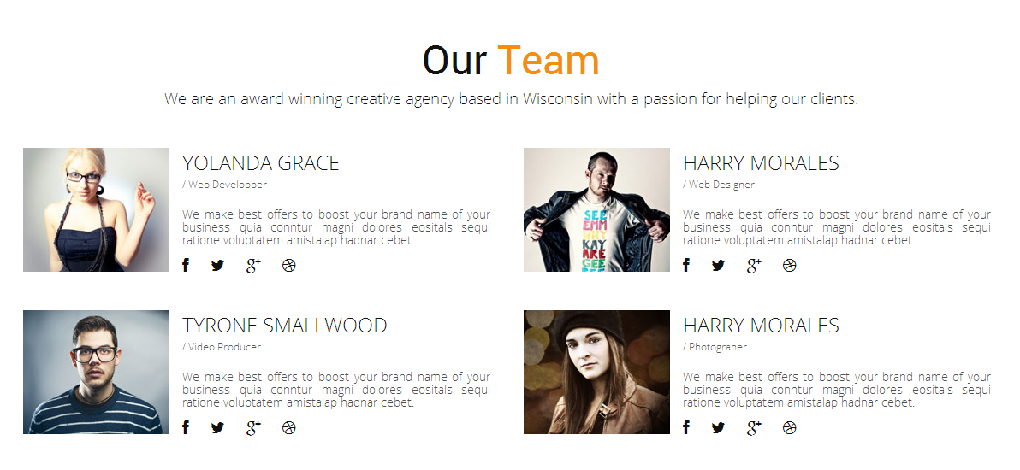

Our Managers Section

This part is like the last one for team. Images and block are responsive and centered. You can include as many persons you need. On hove information and social links will be displayed. If you will need some adjustments please check the file style.css on the team managers’ part.



Best Skills Section

For skills section you have a variety of section included on the page skills.html that you can copy/past the code into your page.

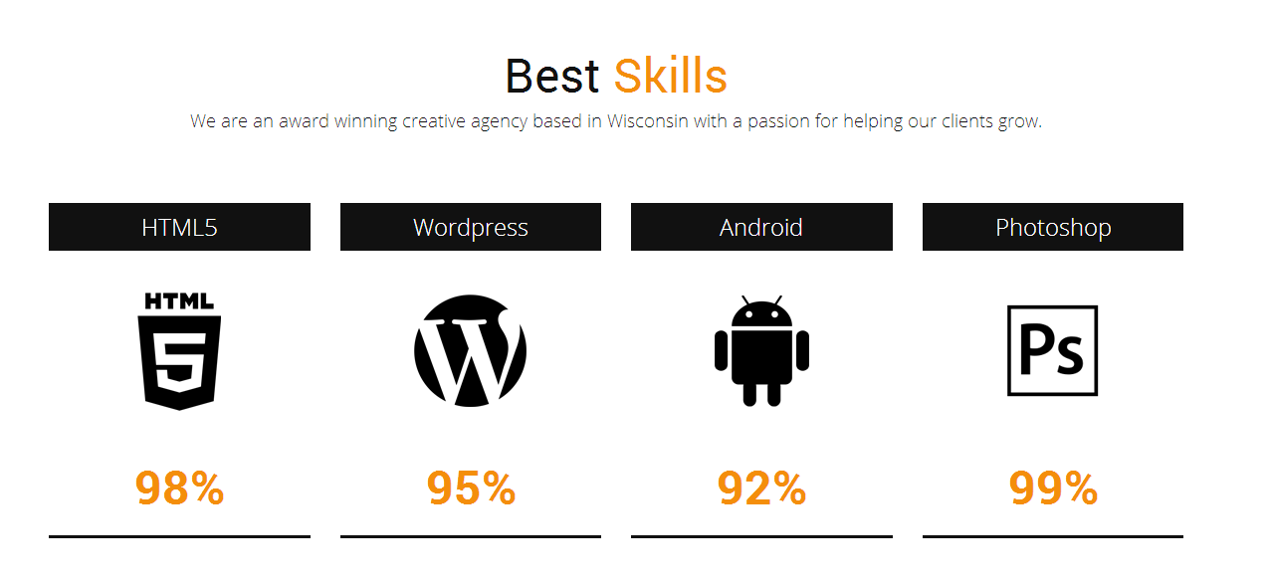

For numbers, they have an animation display, so you have to make modifications on two parts on the code:

<div class="skills_content_nmbr text_color" data-perc="98"><span class="factor">98</span>%</div>

And those two parts need to have equal value the one on the data-perc attribute have the priority to be displayed.

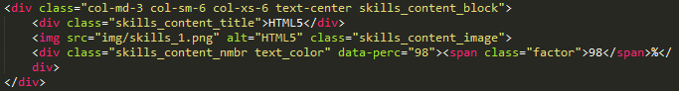

Video Background Section

As mentioned on the top, this section have the same option as the video background on the top, so editing it need youtube URL and editing options on the code.

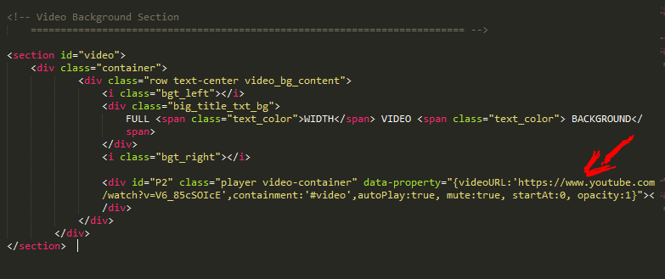

So options can be changed:

* **opacity**: 1 //(int) 0 → Set the opacity of the player;
* **mute**: true //(boolean) mute the audio;
* **showControls**: true // or false If you set the player as background you can show controls adding this parameter;
* **ratio**: ‘4/3’ or “16/9” to set the aspect ratio of the movie;
* **quality**: ‘default’ or “small”, “medium”, “large”, “hd720”, “hd1080”, “highres”;
* **containment**: (string) the CSS selector of the DOM element where you want the video background; if not specified it takes the “body”; if set to “self” the player will be instanced on that element;
* **optimizeDisplay**: true (boolean) will fit the video size into the window size optimizing the view;
* **loop**: true (boolean) or false loops the movie once ended.
* **vol**: 1 to 100 (number) set the volume level of the video.
* **startAt**: 20 (int) Set the seconds the video should start at.
* **autoplay**: true (boolean) or false play the video once ready.
* **showYTLogo**: true (boolean) Show or hide the YT logo and the link to the original video URL.

**showControls**: true (boolean) Show or hide the controls bar at the bottom of the page.

Our Services Section:

From the service page service.html and from the index page, you have many sections to include in this part. Just copy/past the code of the section you need.



For changing icons please check the icons part in this documentation.

Our Price Section

Also this section has many abilities to include, table with 2, 3 or 4 columns for product pricing. The page price.html show al this and you can copy/part you chosen section.

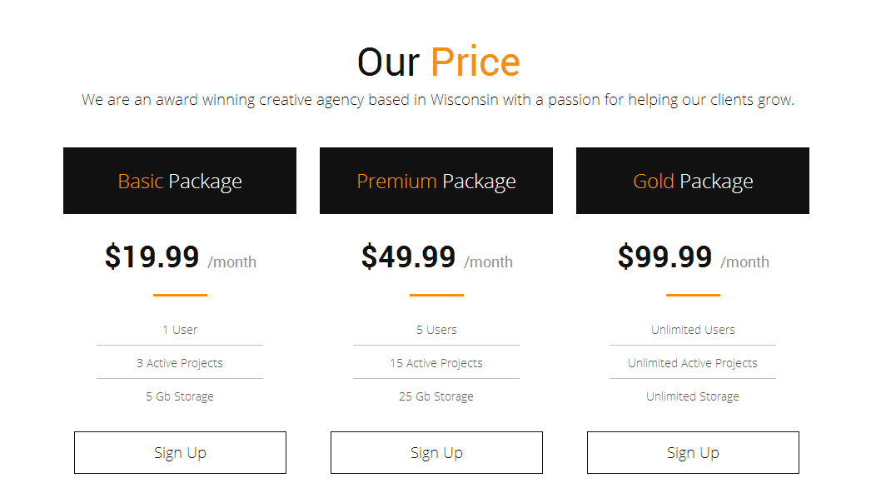

Our Portfolio Section

The portfolio is made by isotope plugin, a great plugin to display filterable and animated portfolio. So editing this part need to steps. One, you must edit the filters section by making what you need and it’s very important that you make the correct “data-filter” attribute, it must be the same as the class you will make in the image DIV. So don’t forget to make the same to make the data filterable and you get good results.

Images in the portfolio is displayed by prettyPhoto plugin. This allow you to display your items as a popup with the ability to make great lightbox display for: single image, images gallery, images slide show, youtube video, vimeo video, iframe, and many other features you can check here :

<http://www.no-margin-for-errors.com/projects/prettyphoto-jquery-lightbox-clone/>

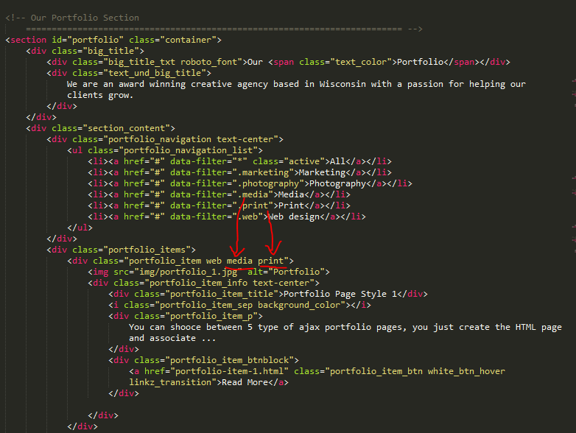

Our Partners Section

In partner section you can include as many logos as you want. The number displayed will be 5 logos.

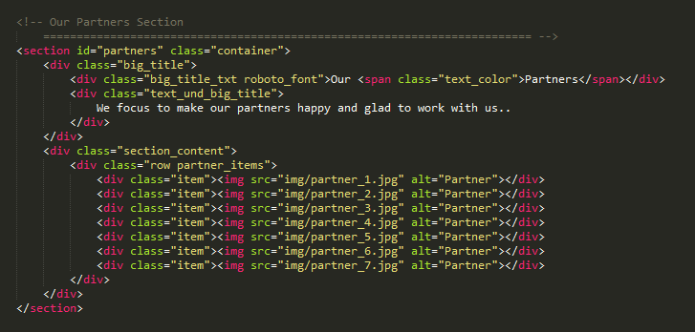

You can chose the number of displayed logos from script.js in JS folder

/* Partners Block */

$(".partner_items").owlCarousel({

autoPlay: 3000, //Set AutoPlay to 3 seconds

items : 5,

itemsDesktop : [1199,4],

itemsDesktopSmall : [979,3],

itemsTablet : [768,2],

navigation : false,

pagination : false

});

Some Testimonials Section

The page testimonials.html has many blocks and sections to include. You just need to change text and images.



Latest Tweets Section

The question here is how to edit this section to get tweets from your twitter account.

First you need to get the twitter API consumer and secret keys:

1. Go to https://dev.twitter.com/apps/new and log in, if necessary
2. Enter your Application Name, Description and your website address. You can leave the callback URL empty.
3. Accept the TOS, and solve the CAPTCHA.
4. Submit the form by clicking the Create your Twitter Application
5. Copy the consumer key (API key) and consumer secret from the screen into your application

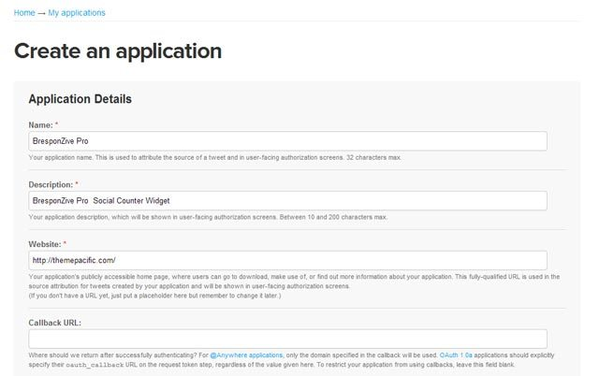

1. Create Your Access Token for OAuth

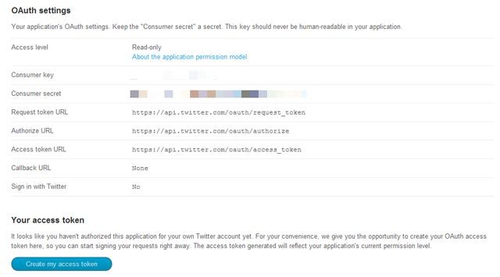

After creating your Twitter Application, you have to give the access to your Twitter Account to use this Application. To do this, click the Create my Access Token.



Get the Consumer Key, Consumer Secret, Acess token, Access Token Secret.

Now go to HTML\js\twitter folder and open index.php file with any editor and change those 4 lines

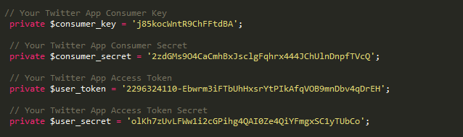

Twitter display needs PHP working on your server.

From The Blog Section

The blog section has many options

* Post with image
* Post with music file
* Post with video
* Post with slider
* Post with quote

And for each port you can have a popup or a link to blog page.

# For the Post with image

You have to change this part of code



# For the Post with music file

You have to change this part of code from HTML page

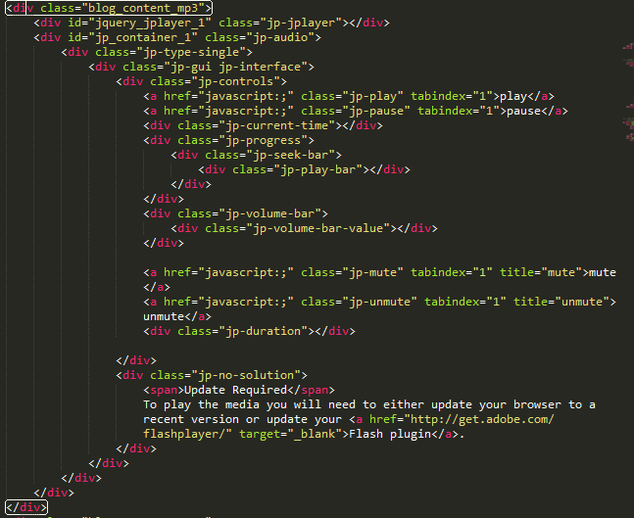

And this part on script.js file

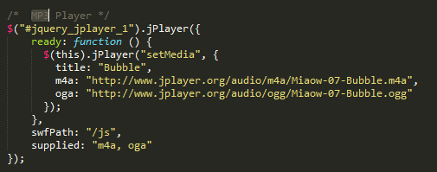

So you need to change the two URLs of m4a & ogg files.

# For the Post with video

You have to change this part of code



You can find this part on the EMBEd part on any vimeo video.

# For the Post with Slider

You have to change this part of code

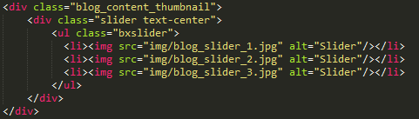

And make links for your images

# For the Post with Quote

You have to change this part of code



And just change the text.

For blog pages you have blog-single.html with a side bar.

Subscribe Section



All subscription emails will be in the file list.txt, use any editor like notepad++ to open it

Link do download notepad++ <http://sourceforge.net/projects/notepad-plus/>

Contact Section

From the page contact.html you have many sections that you can include.

Now we need to configure this contact block. Go to mailer.php file and change those 3 lines:

define( "RECIPIENT_NAME", "Your name" );

define( "RECIPIENT_EMAIL", "youremail@gmail.com" );

define( "EMAIL_SUBJECT", "Message from Sertin" );

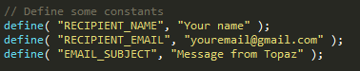

Animation

To animate any block, please check Animation page from animation.html, choose your animation type then add to the block 🡺 wow + animation name

<div class="wow bounce" data-wow-delay="4s" data-wow-iteration="3"><a href="#about" class="btn_fullgb">Start Now</a></div>

You can use **data-wow-delay** for the delay to wait before doing the animation, and **dada-wow-iteration** for the number of repeats for the animation.

Colors:

Color Codes:

Color 1- 955b1c – file (color_1.css)

Color 2- 8e0e05 – file (color_2.css)

Color 3- f48e0b – file (color_3.css)

Color 4- ee3b37 – file (color_4.css)

Color 5- f0762d – file (color_5.css)

Color 6- f2b208 – file (color_6.css)

Color 7- accb03 – file (color_7.css)

Color 8- 458b06 – file (color_8.css)

Color 9- 25c28b – file (color_9.css)

Color 10- 7eb7a4 – file (color_10.css)

Color 11- 278b81 – file (color_11.css)

Color 12- 1cafda – file (color_12.css)

Color 13- 4b99bd – file (color_13.css)

Color 14- 0a83b0 – file (color_14.css)

Color 15- 753faf – file (color_15.css)

Color 16- 9163cf – file (color_16.css)

Color 17- c43ba5 – file (color_17.css)

Color 18- e52ca1 – file (color_18.css)

Color 19- e6135a – file (color_19.css)

Color 20- 969696 – file (color_20.css)

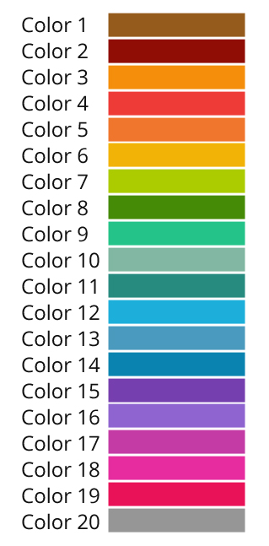

**How to change color:** you have 20 css file named color_X.css, just chnege the color you want on the index header.

Font

This template use google font, you can change the font on style.css, change the second line

@import url(http://fonts.googleapis.com/css?family=Open+Sans:300italic,400italic,600italic,700italic,800italic,400,300,600,700,800);

@import url(http://fonts.googleapis.com/css?family=Roboto:400,100,100italic,300,300italic,400italic,500,500italic,700,700italic,900,900italic);

then change the value on next line

body, p, a, blockquote{

font-family: 'Open Sans', sans-serif;

font-weight: 300;

color: #111111;

}

Images

All images are displayed on the folder /img, they are free for use.

PSD Files:

The template is supported by well layered PSD file.

Sources and Credits

jQuery JavaScript Library v1.10.2

<http://jquery.com/>

Bootstrap v3.0.3

<http://getbootstrap.com>

jQuery Easing v1.3

<http://gsgd.co.uk/sandbox/jquery/easing/>

Font Awesome

<http://fortawesome.github.io/Font-Awesome/>

Modernizr 2.6

<http://modernizr.com/>

jQuery Appear

<https://github.com/bas2k/jquery.appear/>

Easy pie chart

<http://github.com/rendro/easy-pie-chart/>

Pretty Photo

<http://www.no-margin-for-errors.com/>

Smooth Scroll - v1.4.13

<https://github.com/kswedberg/jquery-smooth-scroll>

jQuery One Page Nav Plugin

<http://github.com/davist11/jQuery-One-Page-Nav>

GMAP3 Plugin

<http://gmap3.net>

OwlCarousel v1.3.2

<http://www.owlgraphic.com/owlcarousel/>

Wow animation

<https://github.com/matthieua/>

Nicescroll

<https://github.com/inuyaksa/jquery.nicescroll>

Icons Credit

Thanks for Font Awsome : <http://fortawesome.github.io/Font-Awesome/>

Photo Credits

<http://publicdomainarchive.com/>

<http://unsplash.com/>

<http://picjumbo.com/>

<http://getrefe.tumblr.com/>

<http://www.imcreator.com/free>

**Support**

If you need any help or support we will be glad to help you via [mosaixel.org@gmail.com](mailto:mosaixel.org@gmail.com)